**Sample Output**

1. Air Quality Measuring Sites near SFO, California

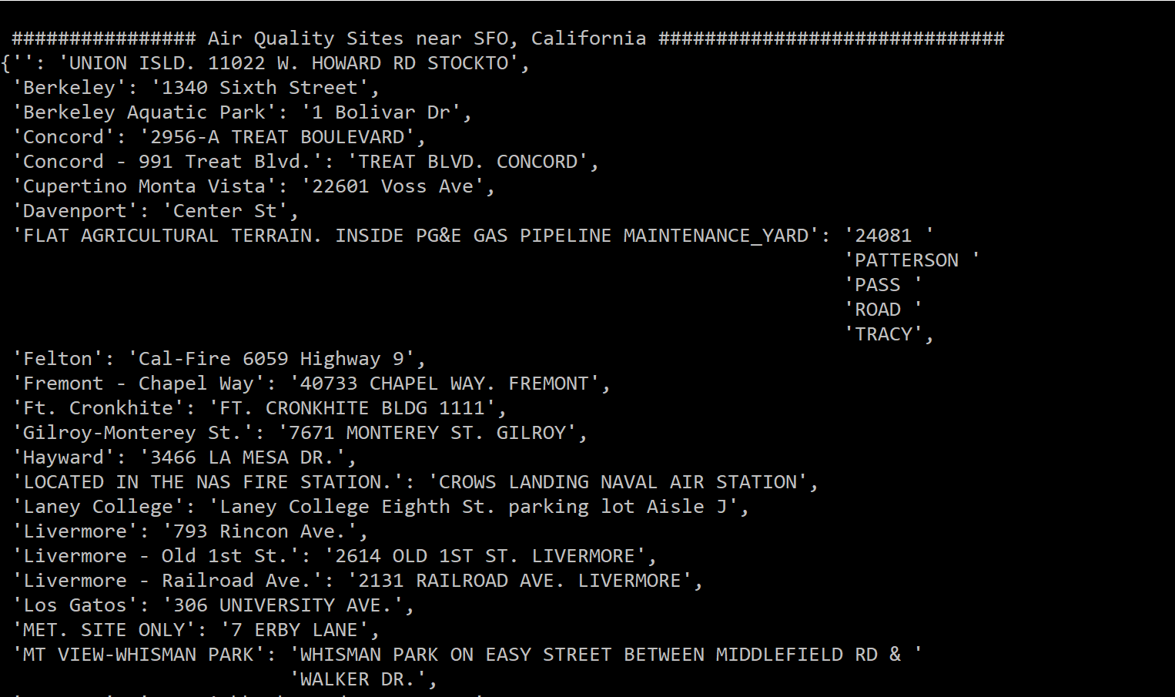

1. Yearly measurement of Pollutant PM2.5 City/State Wise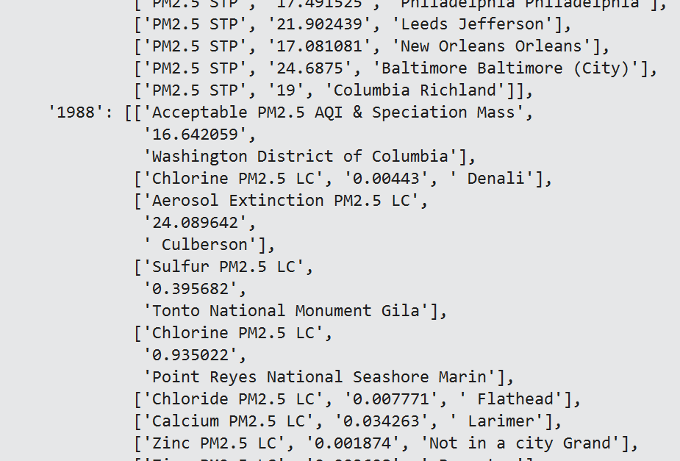
2. Pollutants measured every year